**Module 1 Challenge- Crowdfunding Analysis Report**

Chun Zhao

03/07/2023

UTA-VIRT-PT

1. **Given the provided data, what are three conclusions that we can draw about crowdfunding campaigns?**

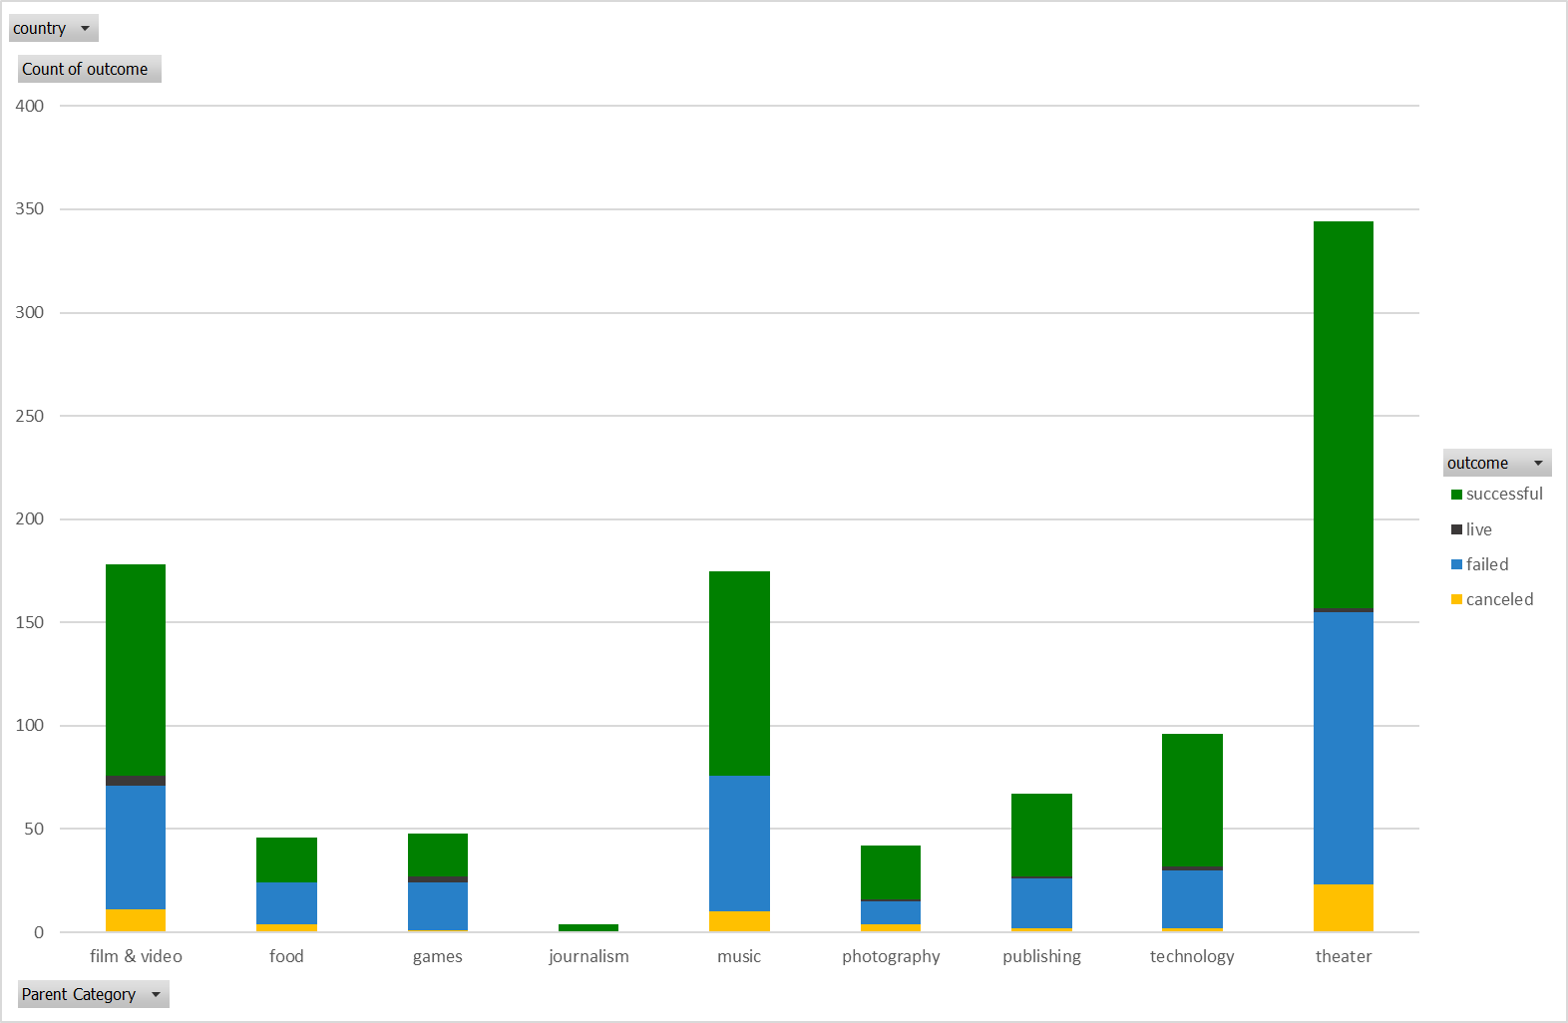I. Theater is by far the most prevalent category, which leads there to be a peak in crowdfunding from May to July.

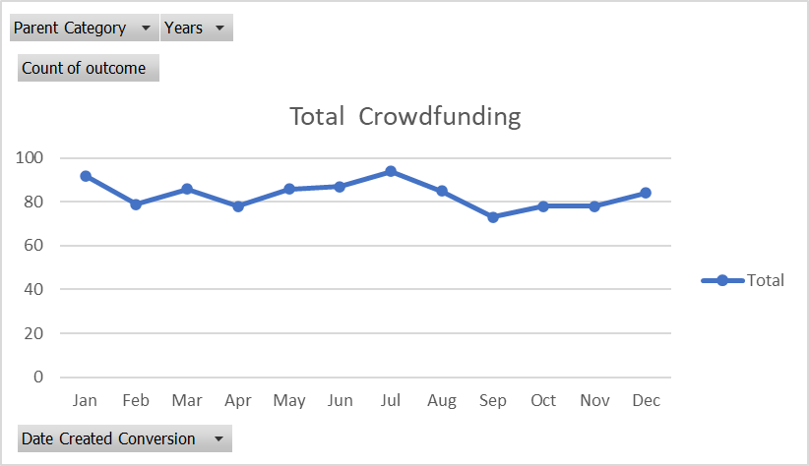

II. 2020 is a downturn for crowdfunding. In this year, the total launched projects decreased to historically the lowest level of 2, and they are both failed. This may be due to the shutdown caused by COVID spreading. This shows Crowdfunding is highly affected by the economic environment, which is an external factor when we are analyzing the company.

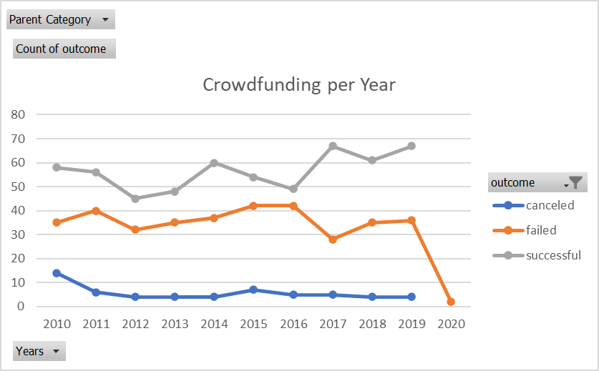

III. While journalism tends to be the most successful parent category (with 100% of the sample’s Crowdfunding campaigns succeeding), journalism also has the lowest average funding goal.



1. **What are some limitations of this dataset?**

This sample may not fully represent the population of Crowdfunding campaigns. For example, in Crowdfunding’s website <https://www.gofundme.com/start> the fundraising categories are divided into medical, memorial, emergency, nonprofit, financial emergency and animals etc., which covered a wider range of categories than this sample showed.

Additionally, there are not any metrics that describe the success of each industry as a whole during the covered time period. It would be helpful to have data that shows whether or not each industry does well or poorly during the relevant time periods. This might help us account for external factors while analyzing the data.

Last but not least, Crowdfunding was founded in 2009, making it a relatively new company. As we could see in the prior analysis, the changes of economic environment, such as spreading of COVID, highly affected the performance of Crowdfunding. So, when we are analyzing this model, we may need to consider multiple external variances when we evaluate its performance. Personal preference such as consumer trust or donors’ preference should also be considered.

1. **What are some other possible tables and/or graphs that we could create, and what additional value would they provide?**

A. Tables showing the most successful categories versus the most unsuccessful categories and detailed data into each category’s level of success. Some possible metrics include:

(1) median, max, and min funding goals per category.

(2) median, max, and min of average donation per category.

(3) median, max, and min of percent funded per category.

(4) median, max, and min length of Crowdfunding campaign timelines per category.

B. It would be very helpful for data analyzing perspective of making outlier testing and generating a table and graph by excluding outliers.